Eyeconic - Glasses Shop Management System

Use-Case-Realization Specification: M30-Remove Storage Box

Version <1.0>

Revision History

|  |  |  |  |
| --- | --- | --- | --- |
| **Date** | **Version** | **Description** | **Author** |
| 04/11/2019 | 1.0 | The first version of remove Storage Box | Nguyễn Tuấn Anh |

Table of Contents

1. Introduction 4

1.1 Purpose 4

1.2 Scope 4

1.3 Definitions, Acronyms, and Abbreviations 4

1.4 References 4

1.5 Overview 4

2. Flow of Events—Design 4

3. Derived Requirements 6

Use-Case-Realization Specification: Remove Storage Box

# Introduction

## Purpose

This document describes how the Remove Storage Box use case is realized within the design model.

## Scope

This document applies to the Eyeconic - Glasses Shop Management System.

## Definitions, Acronyms, and Abbreviations

None.

## References

None.

## Overview

In the following section, Use-Case Realization Specification of the Remove Storage Box use-case of the Eyeconic is provided in detail. The first section is a textual description of the Use-Case specification. The following section contains sequence diagrams describing how the use case is realized in terms of collaborating objects. The third section includes class diagrams with relationships that participate in the realization of the use case. The last section is an analysis of all requirements, such as non-functional requirements, on the use-case realization that are not considered in the design model, but that need to be taken care of during implementation.

# Flow of Events—Design

**2.1. Use-Case Specification**

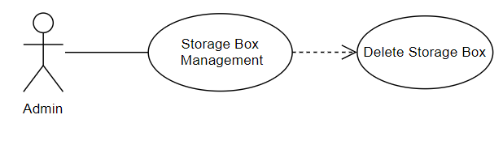

|  |  |  |  |
| --- | --- | --- | --- |
| **Name** | | | Remove Storage Box |
| **Brief Description** | | | Administrator removes a Storage Box from the website. |
| **Actors** | | | Administrator |
| **Flow of Events** | | | |
| **Basic Flow** | | | |
| Step 1: Click the remove Storage Box button in Storage Box management.  Step 2: Confirm to delete the Storage Box.  Step 3: System displays Storage Box management in the website. | | | |
| **Alternative Flows** | | | |
| **Title** | | **Description** | |
|  | |  | |
| **Pre-Conditions** | | | |
| The Storage Box had existed in the database before. | | | |
| **Post-Condition**  Administrator checks the database and the website to ensure that the new Storage Box is removed successfully. | | | |
| **Title** | **Description** | | |
| Success | Storage Boxes is removed to database. | | |
| Failure | The admin is unable to remove new Storage Box to database for one or more reasons and an error is prompt. | | |
| **Extension Points** | None | | |

**2.2. Sequence Diagram**

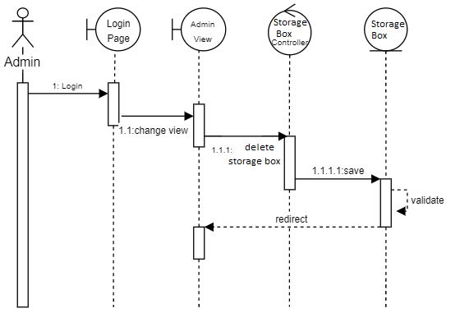

**2.3. Class Diagram**

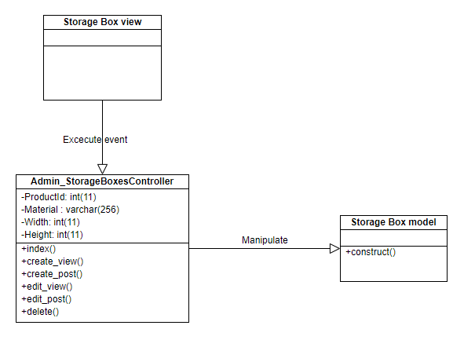

# Derived Requirements

None.